# Become familiarized with Kubernetes concepts

Build from deployment:

1. Build image, name ‘dht:latest’
2. Kubectl create -f dht-service.yaml

# Install Docker

docker --help

docker images

docker run ubuntu

docker ps

docker run ubuntu /bin/echo "Hello docker!"

docker run -t -i ubuntu /bin/bash

# Install and Verify that Kubernetes is installed

kubectl version

kubectl cluster-info

kubectl get componentstatus

kubectl config view

# Install & Run Kubernetes dashboard

kubectl apply -f https://raw.githubusercontent.com/kubernetes/dashboard/v2.0.0-beta4/aio/deploy/recommended.yaml

kubectl apply -f dashboard-adminuser.yaml

kubectl apply -f dashboard-adminrole.yaml

kubectl -n kubernetes-dashboard describe secret

kubectl proxy

Open <http://localhost:8001/api/v1/namespaces/kubernetes-dashboard/services/https:kubernetes-dashboard:/proxy/> select ‘Token’ Authentication and copy the token

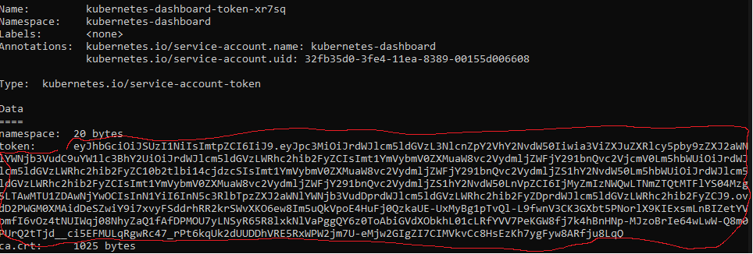

And paste it into the Web UI; to open the Kubernetes dashboard.

# Install

VS Code. [Link](https://code.visualstudio.com/Download)

Microsoft Docker extension. [Link](https://marketplace.visualstudio.com/items?itemName=ms-azuretools.vscode-docker)

# Copy files into container

docker cp index.html [container]:/index.html

docker cp [container]:/index.html other.html

Build docker container

docker build -f myDockerImage -t my-website .

|  |  |
| --- | --- |
| docker run --rm -it -p 8080:8080/tcp dht:latest | Run the website |
| docker stop <container-name> (44fd788380ea) | Stop website |
| docker system prune -a | Cleanup docker |
| docker network create --subnet=222.222.0.0/16 --ip-range=222.222.0.0/24 --gateway=222.222.0.1 dht-net | Create network |
| kubectl create -f dht-service.yaml | Create service |
| kubectl expose deployment/dht-deployment --port=8080 --target-port=80 --type=NodePort | Expose service |
| kubectl get ep dht-deployment | Get deployment |
| kubectl get deployments | Get all deployments |
| kubectl get svc | Get services |
| kubectl delete deployments,svc dht-deployment | Delete services |

http://localhost:808?

docker stop ng-original